* ***What is the difference between PVM and HVM?***

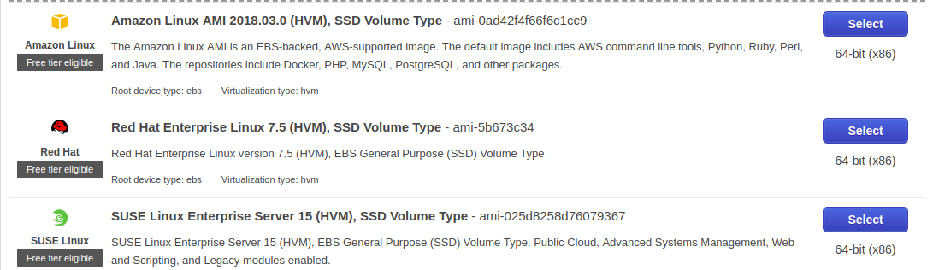

*There are many more HVM’s in AWS a few are listed above*

### ***HVM***

*The HVM virtual machine has the benefit of hardware acceleration. With hardware acceleration, the Intel or AMD chip that is running on the host hardware will intercept some of the system calls that are doing specific operations and process them in hardware, rather than in software. The latest chips have focused on the most heavily used system calls; the virtual to physical memory translations. This is a huge benefit, since these calls are done so frequently. Newer chips in the works will be extending this to do I/O and network calls as well.*

*The down side is that in the HVM model, most I/O and network operations are currently done in software, with is problematic, since all of the code to do an I/O operation is done in the virtual machine and then intercepted by the host and essentially redone at the host level. This tends to make I/O and network slow.*

### ***Paravirtualized***

*The paravirtualized machine has a kernel and drivers that are aware that they are running on a virtual machine and makes choices based on that. So, when an I/O operation occurs on the virtual machine, most of the work is handed off directly to the Dom0 system to handle, thus reducing the duplication of effort. Thus a paravirtualized machine will perform network and I/O operations much faster than the HVM machine, but at the expense of the memory accelerations that the HVM system has.*

* ***Consider a scenario, you have just launched EC2 instances and you are unable to ssh into it, what all things will you check to troubleshoot this.***

*1.Firstly I will check that whether the Security Group(s) permits access to EC2 instance over SSH from the my IP address. If not then I will choose to edit it from the description tab and then add a rule to it.*

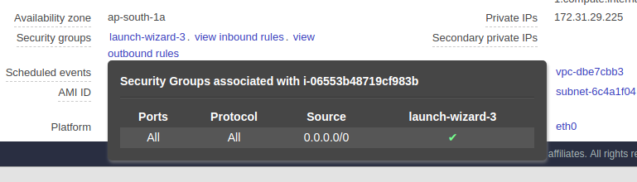

*2.The next step will be to make sure that VPC route table is configured to allow trafic to and from the Internet . To do so I will choose Route Tables and then select VPC route table from the list. Else I will choose Internet Gateways and copy the ID of it and edit the route points to 0.0.0.0/0 to the Internet Gateway ID and save the route table*

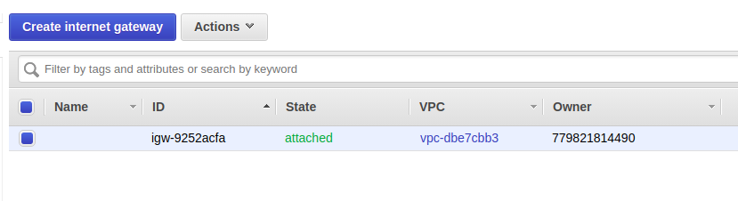

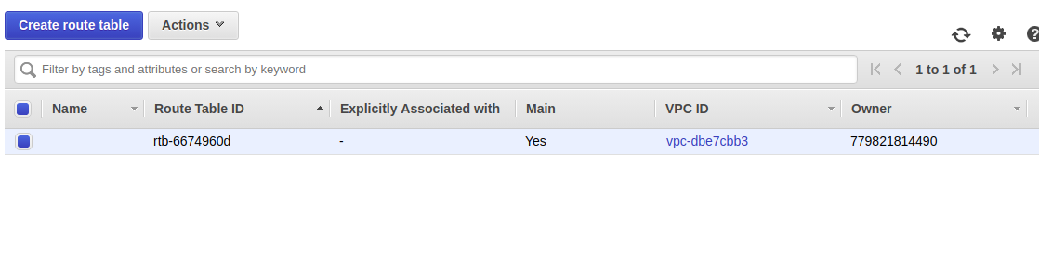

*3. I will also check whether the ACL rules allow inbound and outbound IPv4 traffic or not.*

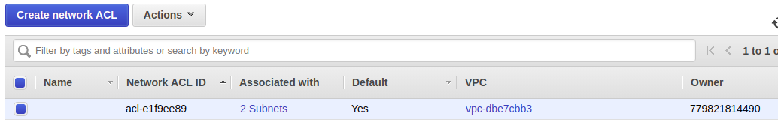

* ***Launch EC2 instances with user-data (install Nginx and print hello world on the default page), using AWS CLI***

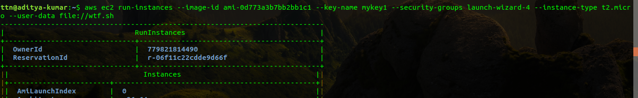

***Command****:- aws ec2 run-instances --image-id ami-0d773a3b7bb2bb1c1 --key-name mykey1 --security-groups launch-wizard-4 --instance-type t2.micro --user-data file://wtf.sh*

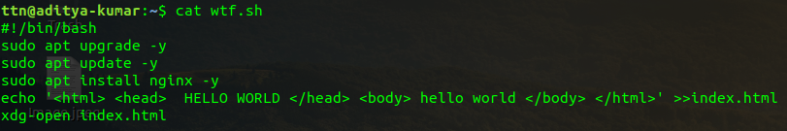

*Due to user-data the nginx was found pre-installed in the instance*

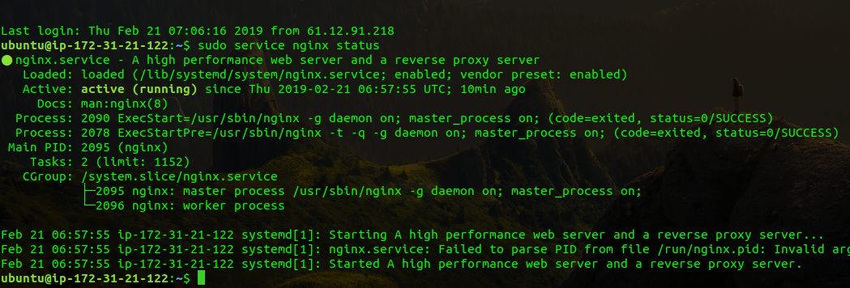

* ***Add memory metrics for the instance in the cloud watch***

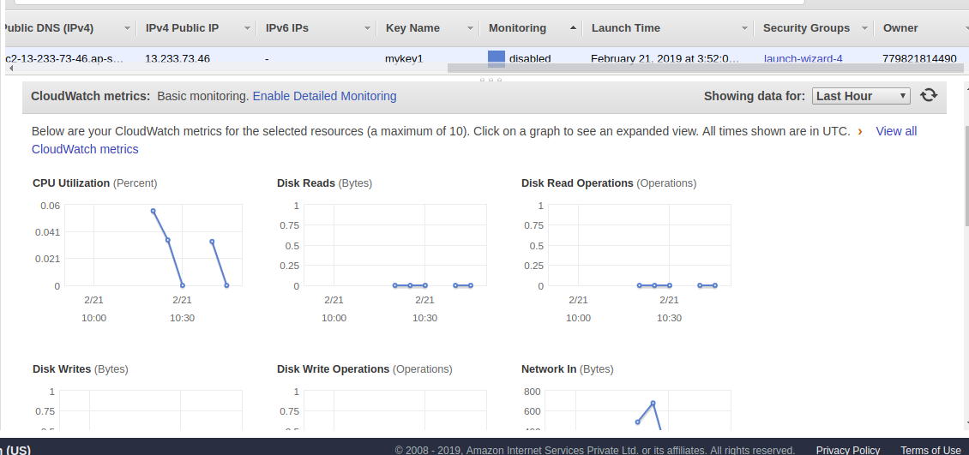

*The following shows that the instance is enabled with some basic monitoring*

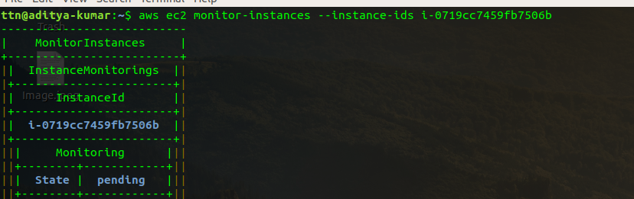

* ***Increase EBS volume size from 8 GB to 20 GB without rebooting the server on the instance created above***

*Before increasing the EBS volume size*

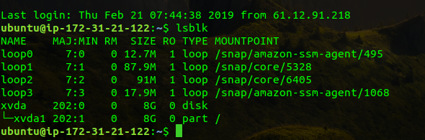

*Now upgrading the volume from the AWS console*

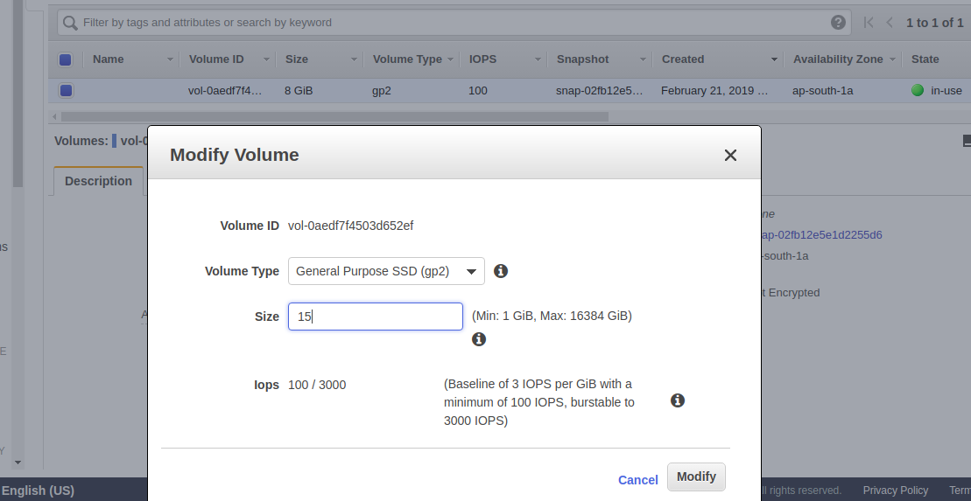

*After upgrading the volume in AWS Console*

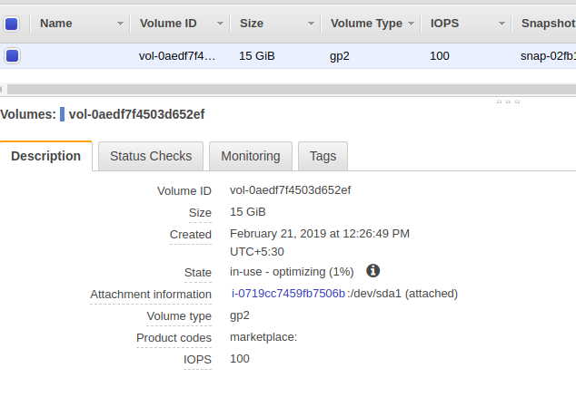

*The changes after the volume is increased*

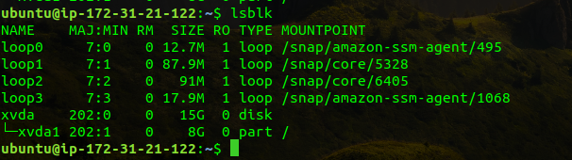

* ***Convert EBS disk to encrypted EBS disk on the instance created above***

*Firstly create a snapshot of the current EBS disk*

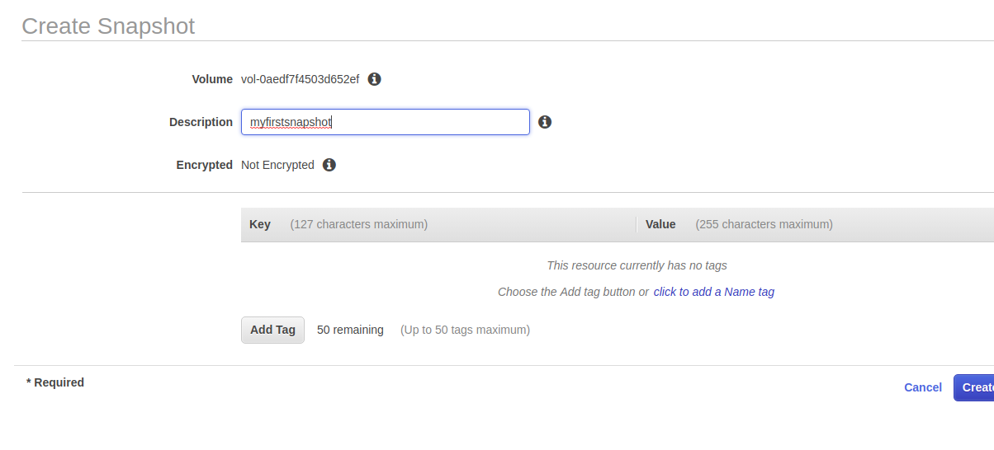

*Now copy the newly created snapshot and select the checkbox for encryption*

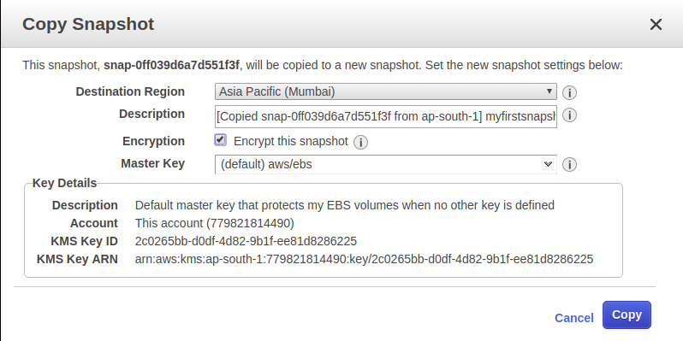

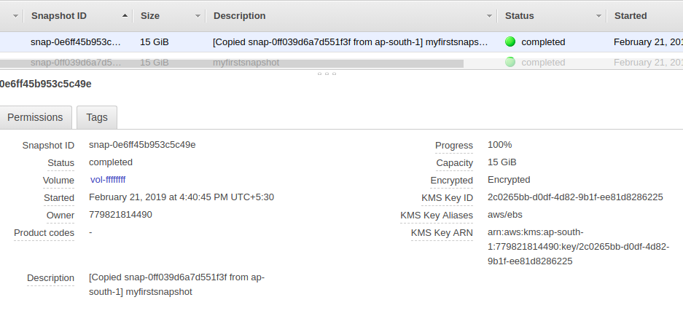

*Now after the new copy of the snapshot is being created ,select create volume from action and create a new volume where encryption flag is by default set to true.*

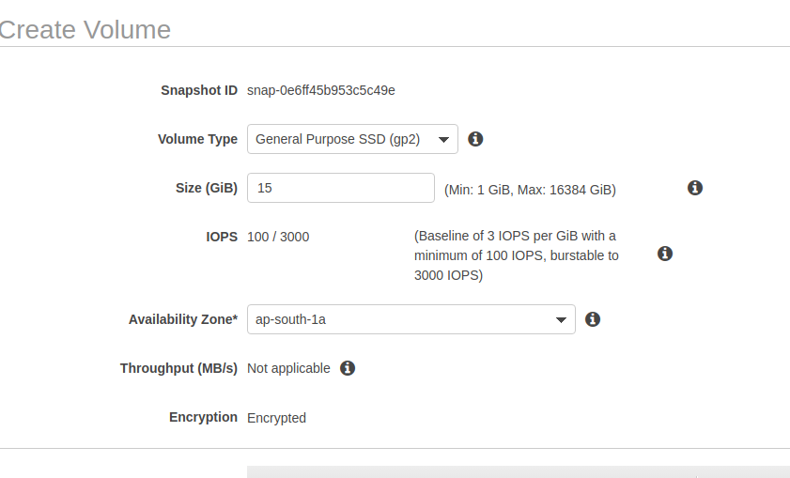

*Now attach the new encrypted volume to the running instance.*

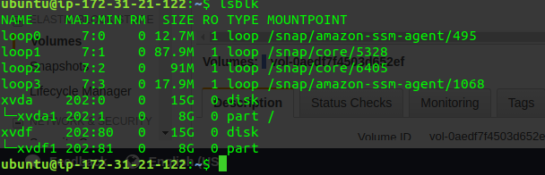

* ***You have lost the private key for one of the servers, how will you recover ssh access to the server.***

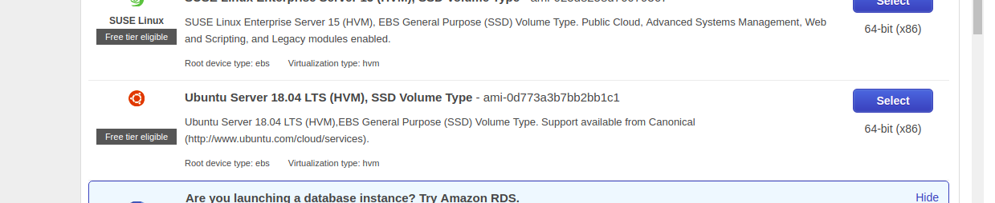

*In order to perform the same ..lets create a new instance (UBUNTU)*

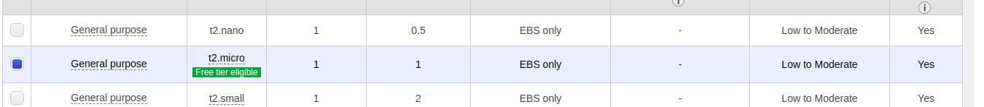

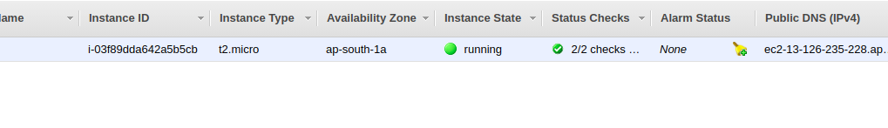

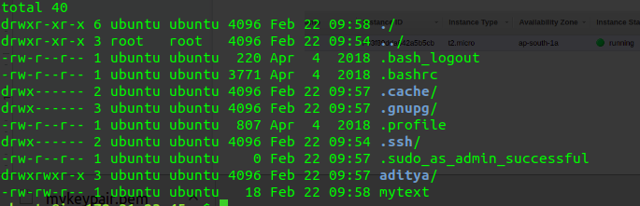

*In order to know that we are in the same volume let’s create some files in the instance*

*( adtya [directory], mytext [txt] )*

*Now assuming that I have lost my keys and I need the SSH access again to the same*

*Let’s take a screenshot of the attached volume*

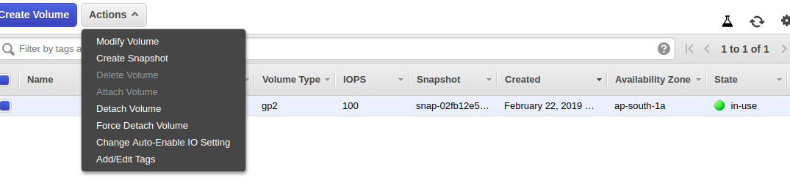

*Now create a new volume from the screenshot and attach that new volume to a new instance*

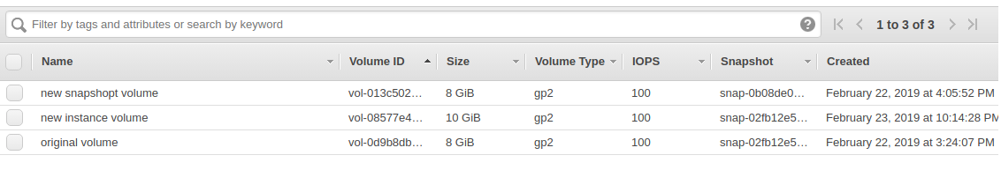

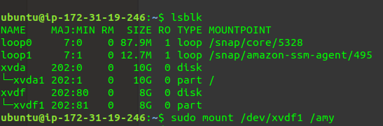

*And now mount that volume in the instance and replace the key file present in dev/xvda to dev/xvda1*

*The command will be as follows*

*Sudo cp /home/.ssh/authorized_keys /amy/home/ubuntu/.ssh/authorized_keys*

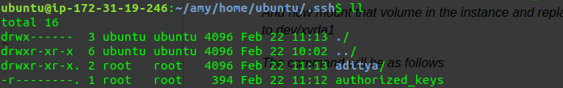

*And now unmount the volume dev/xvdf1 and attach it to the original instance .*

*Now you can easily ssh the original instance from the new key*